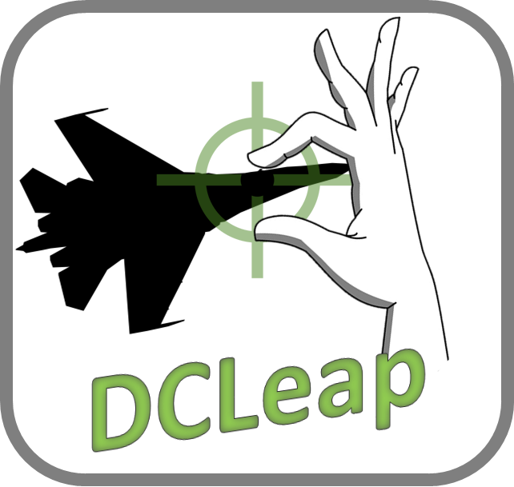

v 1.10c

Decembre 26th 2019

# Overview

DCLeap is a Windows application, running in background, to control the movements and events of the mouse and the achievement of specific actions related to the gestures of the hands, all in a virtual reality environment.

**DCLeap is not compatible with Oculus and PiMAX devices.**

## DCLeap software and hardware

DCLeap is composed of :

* Mouse movement management module ;
* Module for managing events linked to the mouse (right and left clicks);
* Module for detecting interactions in the context of hand gestures.

DCLeap was developed in C # with Unity and uses the following solutions :

* Win32 C# mouse ;
* InputSimulatorPlus by TChatzigiannakis ;
* LeapMotion Core SDK for Unity ;
* LeapMotion Interaction engine for Unity ;
* OVRLay by BenOtter.

The prerequisites of DCLeap are:

* Virtual reality HMD ;
* Headmounted LeapMotion device ;
* DCS World ;
* SteamVR, beta or stable ;
* Drivers CBuchner *driverleap (*<https://github.com/cbuchner1/driver_leap>*)*;
* Drivers SDraw *driverleap* (<https://github.com/SDraw/driver_leap>)

## Installation

Starting from the premise that DCS World, SteamVR and the two "driverleap" are already installed, unzip the DCLeap.7z archive to the location of your choice. Then, open DCLeap.exe.

At first use, it is necessary to enter the resolution of a single screen of your VR headset, for example:

* WMR :1440 x 1440 ;
* HP Reverb : 2160 x 2160 ;
* HTC Vive Pro : 1440 x 1600.

Once filled in, click “Save Settings” button.

It is imperative to perform this step because DCLeap will recover two registry keys containing the specified resolutions in order to generate the cursor movements.

This registration in the registry is the only entry generated outside the folder in which you unpacked DCLeap.

These registry keys are under:\Computer\HKEY_CURRENT_USER\Software\Leap4DCS\DCLeap

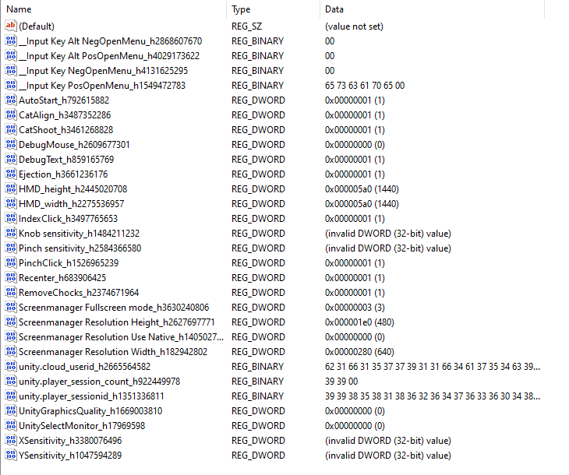

Check the creation of these keys by launching Regedit via the Windows command prompt (Win + R key).

If the keys have been correctly generated and the associated values ​​are correct, run the DCLeap.exe executable.

Normally, the entered values ​​should be italicized in the input fields. You should see the Unity window below, make sure the windowed mode is enabled, and then click "Play! ".

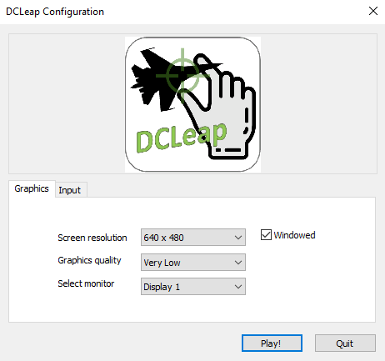

# Usage

## Main Menu

When DCleap is launched, you will access this window, Main Menu, where you can ;

* Enable the gesture recognition feature ;
* Allow hand signals;
* Allow texts popup ;
* Define click method by allowing pinch and/or index trigger gesture;
* Define the sensitivity of the pinch gesture ;
* Define the knob sensitivity;
* Define mouse sensitivity ;

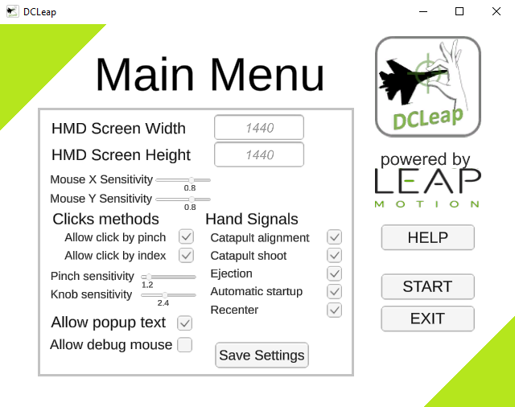

## Help Menu

From this window you can access help reminding the different gestures implanted.

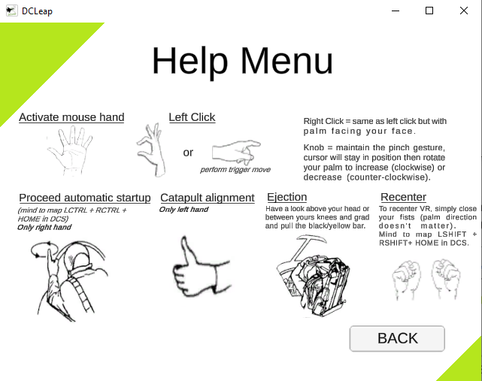

## Start Button

Once you have pressed the Start button, you should see two red and green squares appearing in your VR headset, indicating the activation of the virtual mouse.

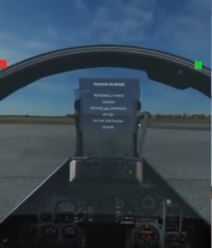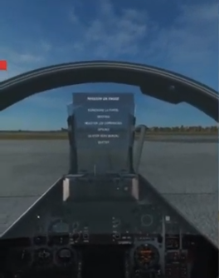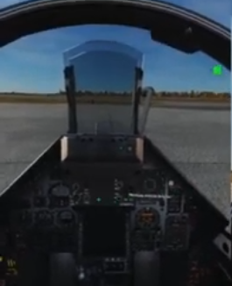

Figure 1 – From left to right - both hands move the mouse, only the left hand, only the right

The red square indicates that the mouse control is slave to the left hand, the green square indicates that the control is slaved to the right hand. In order to avoid any disruption related to activation of both hands tracking, it is best to assign mouse tracking to one hand at a time.

DCLeap will tell you when right click is available as shown under (blue square around green/red square).

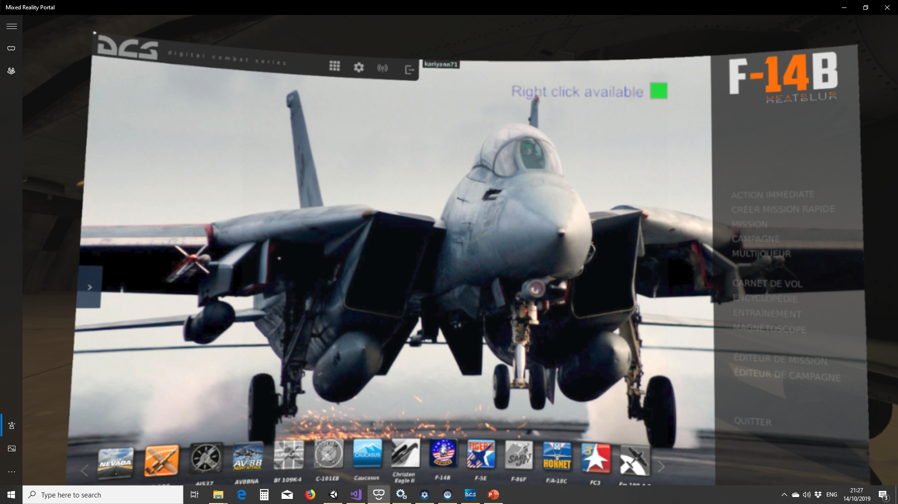

### Trigger clicks

To execute a trigger click, you need to extend your thumb, your index, retract middle, pinkie and ring and after execute trigger gesture.

### Pinch

Pinch is used to execute standard click and knob rotation. To execute pinch gesture, all fingers can be extended. When you activate pinch, mouse cursor stay in fixed position, then you can rotate your wrist (maintain pinch gesture) as you will be rotating a knob. Sensitivity in accordance with Main Menu set.

### Catapult shoot

DCLeap allow you to execute catapult shoot with the salute gesture. Currently this action is mapped to LShift + U.

When you execute “Salute” you will see “Catapult Shoot !” in red letters on top right of your HMD (if Allow debug text is ticked in the Main Menu).

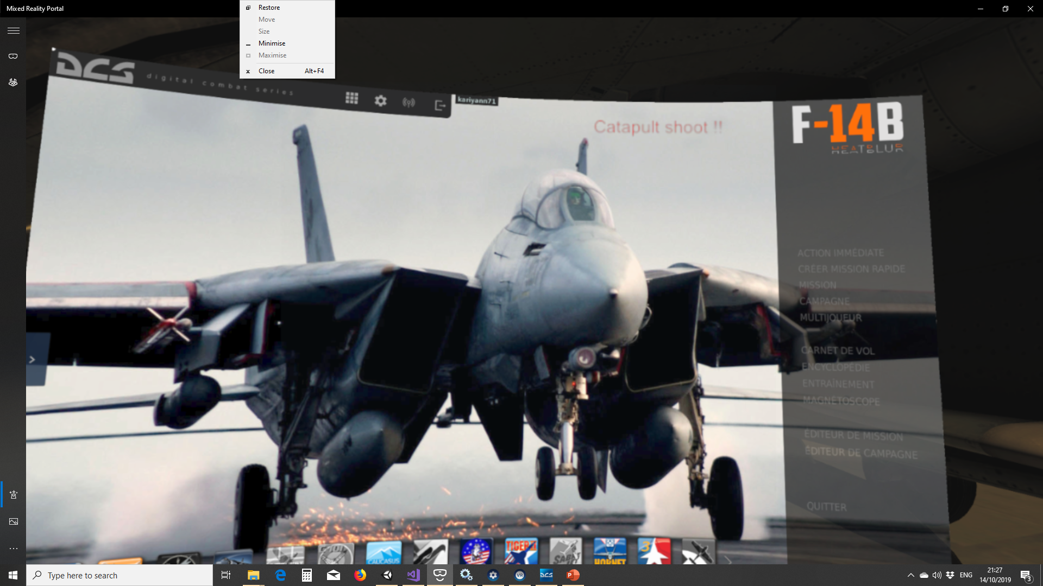

### Catapult alignment

You can align your aircraft to catapult (Keyboard U) with Thumb up gesture. As for catapult shoot, you will see “Catapult Align” in red letters (if Allow debug text is ticked in the Main Menu).

### Start-Up

You can execute an automatic start-up procedure by pointing right index finger vertically and gently circling your hand (index must point to the sky for 2 seconds). Mind to map LCTRL + RCTRL + HOME as keybind for automatic Start-up command for your favourite aircraft (this can be done by performing fists closed gesture).

### Recenter VR view

You can execute a VR recenter view by closing both fists, palms directions don’t matter.

Mind to map LSHIFT + RSHIFT + HOME (this can be done by performing fists closed gesture).

### Ejection

You can call ejection command by grabbing one of the two handlebars over your head or between your knees. When your hands will be close the handle, they will be shown in order to help you to grab the handle.

When grabbed, you’ll have 1 seconds to revert before DCLeap will execute ejection’s command.

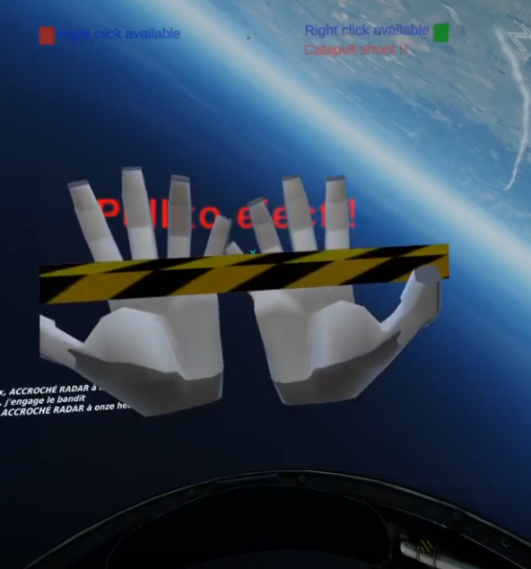

## Quit

To exit the application, press the LCTRL + Escape keys. Then click on the "Quit" button in the main menu.

Other, DCLeap automatically quit when SteamVR is shutdown.

# To go further, or to better understand

## Pinch gesture

Here is the illustration under Unity of the pinch gesture zone (the red one) and the release pinch zone (the blue one).

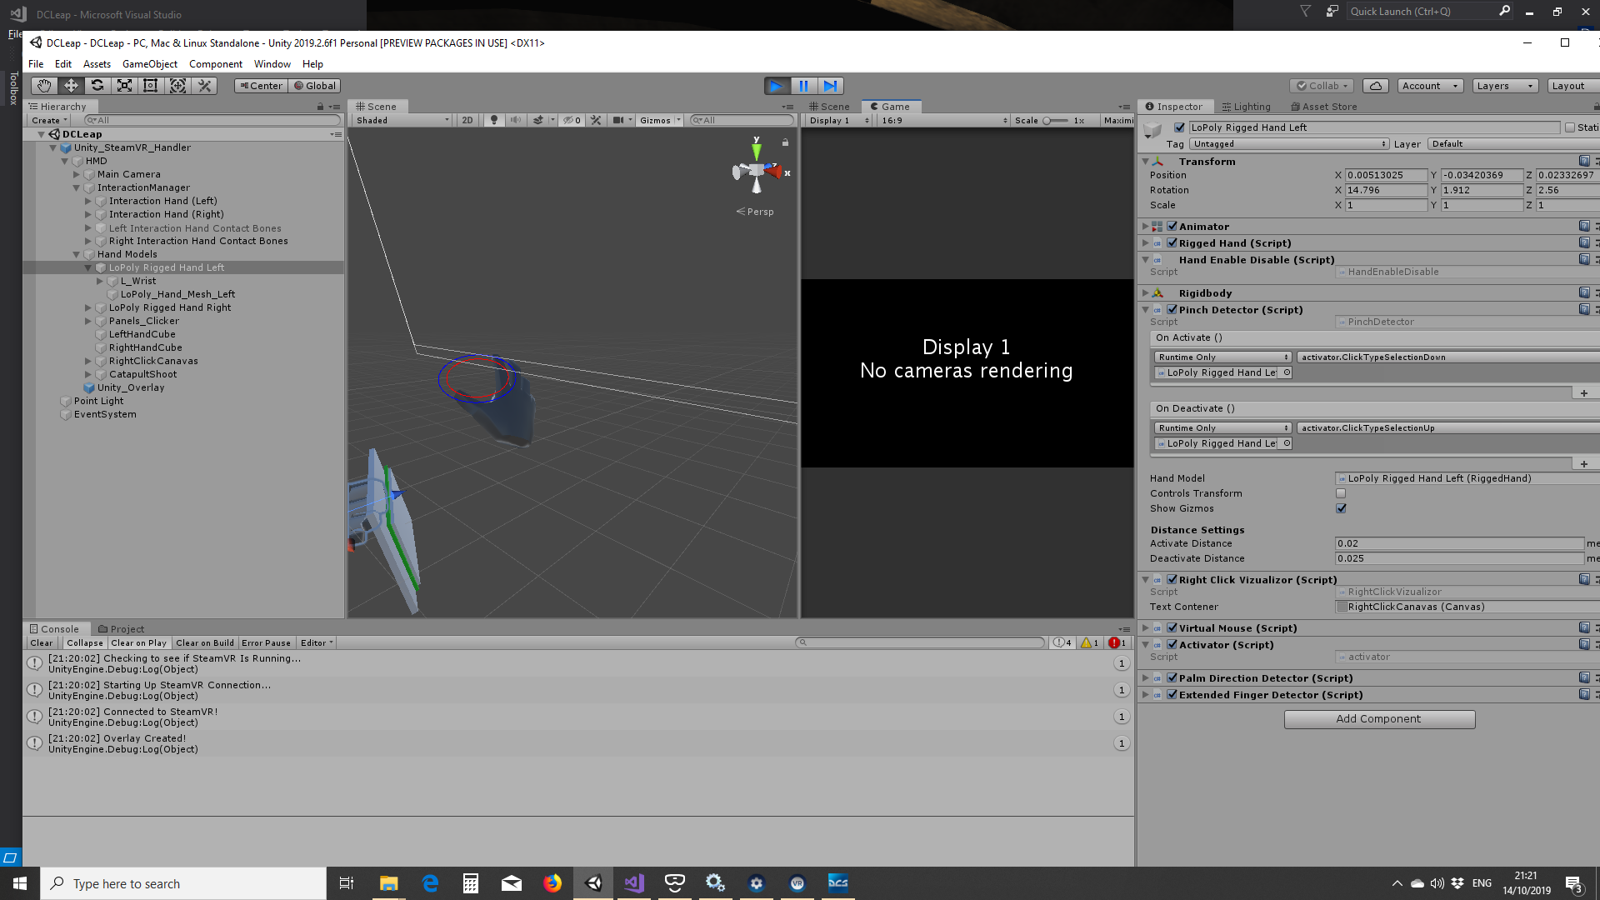

## Palm facing zone

When the white line (line between the HMD and the palm) enter in the red cone, LeapMotion detect your hand is facing your head. Currently the red cone is set at 45°.

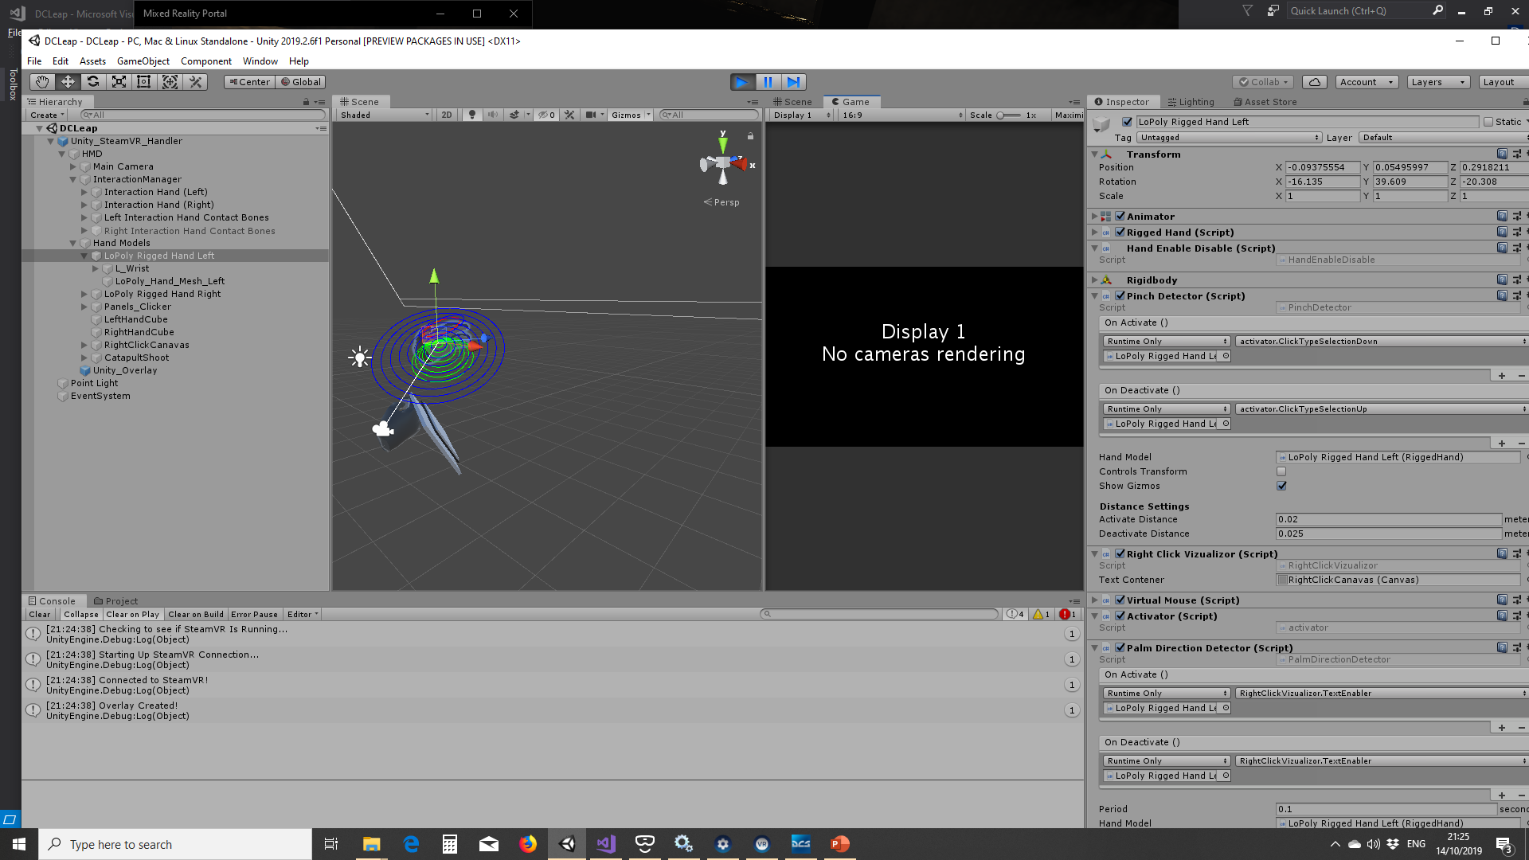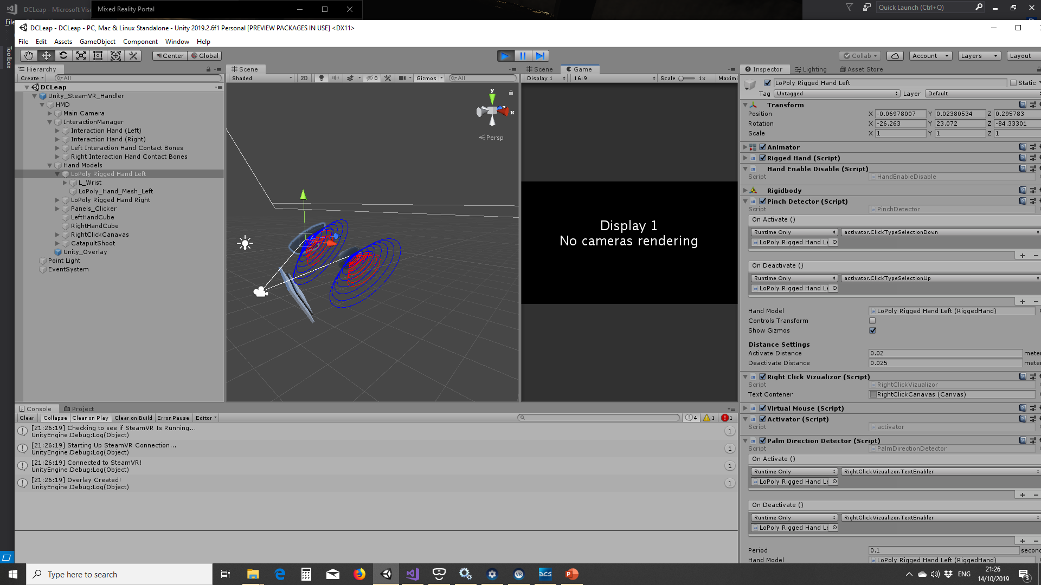

## Catapult alignment

## Automatic start-up